Electronics II  2009-2010 mod. 1  Problem sheet 7  P. Stallinga |   MIEET 3º ano
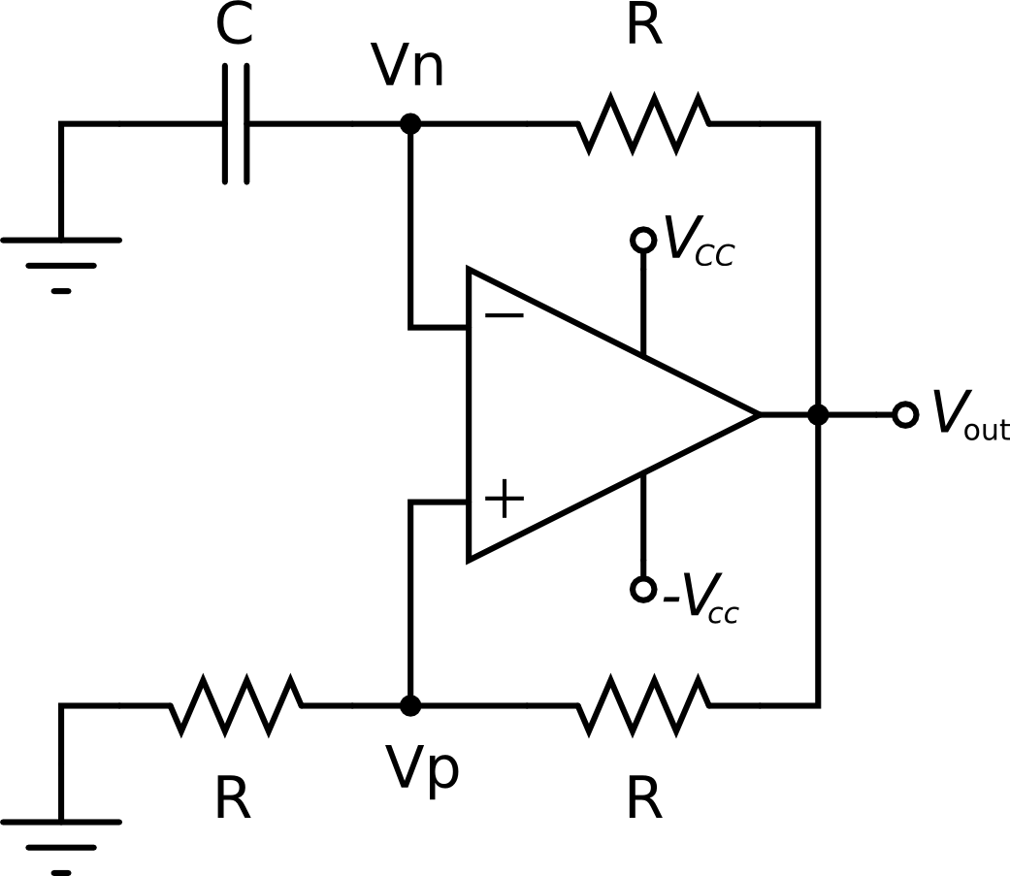
Figure 1: Relaxation Oscillator based on an ideal op-amp and two feedback loops, one containing a capacitor.

The Relaxation Oscillator shown in Figure 1 is based on periodic charging and discharging of the capacitor C.
- Draw plots of the signals at V_{n}, V_{p} and V_{out} as a function of time.
- Determine the oscillating frequency as a function of the parameters.

- - - - -

Consider a feedback amplifier for which the open-loop transfer function A(s) is given by

(s = jω). Let the feedback factor β be a constant independent of frequency. Find the frequency at which the phase shift is 180º. Then, show that the feedback amplifier will be stable if the feedback factor β is less than a critical value β_{cr} and unstable if β ≥ β_{cr}, and find the value of β_{cr}. Phase margin: 0º or 45º. (Sedra & Smith, Ex. 8.10).

