Electronics II  Problem sheet 4  P. Stallinga |   MIEET 3º ano

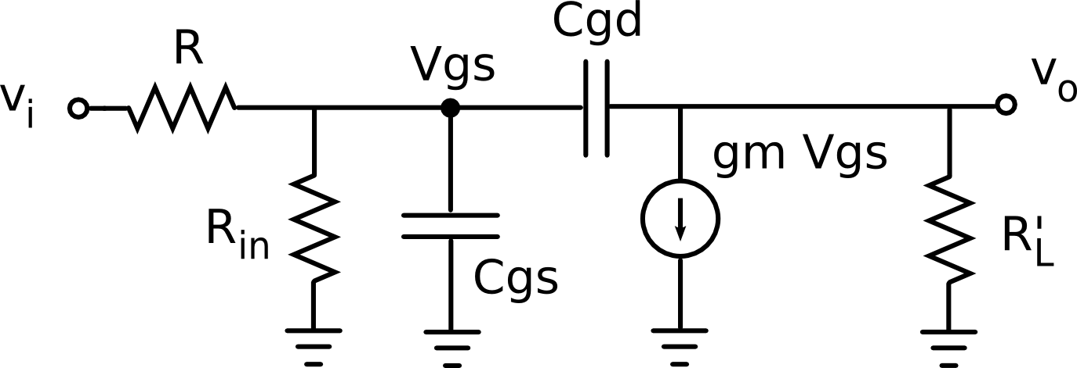
The figure above shows an equivalent circuit of an common-source FET amplifier. The input signal comes from a signal generator with an output resistance R. R_{in} represents the input resistance of the FET stage and is caused by the gate-bias resistances. R_{L}' is the parallel equivalent resistance composed of load R_{L}, drain resistance R_{D} and FET output resistance r_{o}. Capacitors C_{gs} and C_{gd} are internal capacitors of the FET.
R = 100 kΩ, R_{in} = 420 kΩ, C_{gs} = C_{gd} = 1 pF, g_{m} = 4 mA/V, R_{L}' = 3.33 kΩ.

a) Determine the mid-band gain, A_{v} = v_{o}/v_{i}.
b) Determine the bandwidth of the circuit.

