Electronics II  Problem sheet 1  P. Stallinga |   MIEET 3º ano

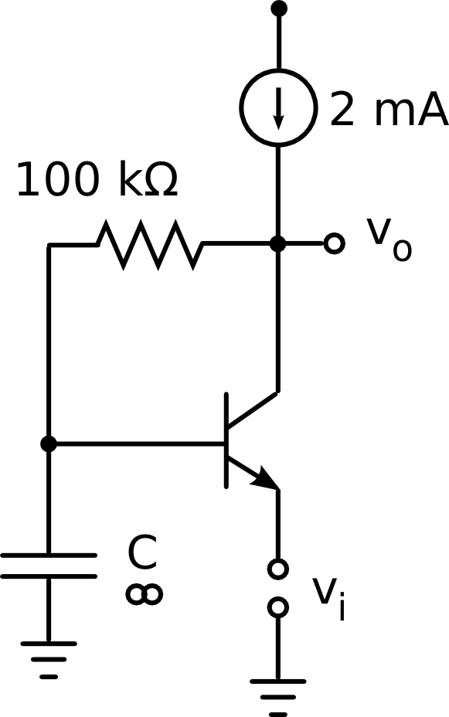
β = 99, V_{A} = 100 V.

a) What is the name of the amplifier above?
b) Calculate the bias point
c) Calculate the signal gain of the circuit A_{v} = v_{o}/v_{i}
d) Calculate the output resistance, r_{out}
e) Calculate the input resistance, r_{in}

